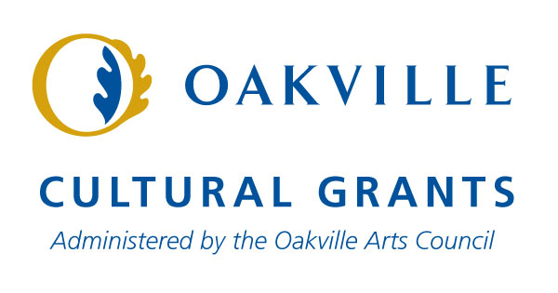
Final Report 2020

Welcome to the Final Report for the Cultural Grants Program. This report is intended to gather information about your organization's activities that most closely align with the 2020 funding cycle (January - December 2020). If your activities will take place after the reporting deadline, please make sure you complete the progress report questions.
If this is your first final report and you have questions about what activities and financial information you need to provide, please contact the OAC.
If you did not receive funding through the Cultural Grants Program in 2020, you do not need to complete this form.

If you are completing a report for a previous year, please contact the OAC for assistance.

If you are applying for a Cultural Grant for the first time, you should complete a Statement of Interest instead of this document.

Please note that you will not be able to save the survey document and return to it at a later date. A "working document" has been created for this purpose. A link to the document was included in an email sent to your organization and can also be found on the OAC website on the Cultural Grants page. Please do not submit the working document; when all the questions are complete, enter them using the Survey Monkey link and click on the submit button at the end of the survey.

1. Organization Information
Contact Name
Organization Name
Address 1
Address 2
City
Prov
Postal Code
Phone#
Email
Website

2. Legal Information
Fiscal year end (d/m)
Date of incorporation: (d/m/y)
Charitable/Not-For-Profit registration #

3. Organizational Profile
# of Full-time Employees
# of Part-time Employees
# of members (for organizations that have paid membership programs)
% of members residing in Oakville (for applicable organizations)

4. What fiscal year are you reporting on? This should be the most recent fiscal year completed, i.e.July 1, 2019 - June 30, 2020.

5. What grant amount did you receive in 2020?

6. What were the goals of your funding request for 2020?

7. What were the results in meeting your goals, based on your measures? Be specific in how you used the grant funds.
To support organizational sustainability
To support volunteer recruitment, training and development
To build audience reach (i.e. ticket buyers, consumers of art)
To engage new participants (i.e. members, volunteers)
To celebrate multiculturalism and educate the public on diverse art forms
To develop artistic programming
To foster intellectual, social, physical, and emotional growth and well-being through arts and culture
To provide accessibility and opportunities in arts and culture to all income levels to increase the quality of life for all residents
To create job growth in the arts and cultural sector
To help leverage further funding from other sources (i.e. grants, sponsors, donors, etc.)
Other

8. We understand that the 2020 funding year will have presented many challenges to grantees due to COVID-19 and that some organizations may not have been able to meet the goals outlined in their original grant application. Please let us know how the pandemic affected your organization specifically.

9. Did your organization find new ways to accomplish some of your goals? If so, please tell us how.

10. Provide the total number of activities programmed in each applicable area during the reporting fiscal year:
total # of classes / workshops
total # of performances
total # of exhibitions
total # of events
total # of festivals
total # of collaborations / partnerships

11. Beside the appropriate categories, list all of your activity names and the date(s) on which they occurred in your reporting fiscal year:
classes / workshops
performances
exhibitions
events
festivals
collaborations / partnerships

12. List the total attendance for any applicable area based on the activities of your group that occurred in your reporting fiscal year:
classes / workshops (total # of people)
performances (total # of people)
exhibitions (total # of people)
events (total # of people)
festivals (total # of people)

13. Tell us about your partnership/collaborations in the community, if applicable:

14. How did your organization benefit from volunteer assistance?

15. How many volunteers worked with your organization during the reporting year?

16. How many hours did your volunteers contribute?

17. Please provide a brief explanation of any in-kind support received and the total fair market value of the in-kind support received.

18. Progress Report (if applicable): If you received funding in 2020 and this funding is not a part of your 2019 - 2020 report, but will be reported on in your 2020 - 2021 report, indicate your program goals and measures:
To support organizational sustainability
To support volunteer recruitment, training and development
To build audience reach (i.e. ticket buyers, consumers of art)
To engage new participants (i.e. members, volunteers)
To celebrate multiculturalism and educate the public on diverse art forms
To develop artistic programming
To foster intellectual, social, physical, and emotional growth and well-being through arts and culture
To provide accessibility and opportunities in arts and culture to all income levels to increase the quality of life for all residents
To create job growth in the arts and cultural sector
To help leverage further funding from other sources (i.e. grants, sponsors, donors, etc.)
Other

19. Progress Report (If applicable): Are you having any challenges in meeting your 2020 goals? If so, what are the conditions to these challenges? How are you re-working operations to address these challenges?

20. We wish to apply for a 2021 Town of Oakville Cultural Grant:
Yes
No

21. Please provide a brief explanation indicating what the funds will be used for in 2021 (300 words or less)

22. We have provided the following information to the Oakville Arts Council c/o Bernadette Ward:
Emailed current Board/Executive List with names, positions and tenures to bward@oakville.ca
Emailed audited or year-end financial statements or balance sheet and profit/loss statement for 2020 to bward@oakville.ca
Emailed updated Cultural Grant financial document to bward@oakville.ca

23. Terms and Conditions
We have read the eligibility criteria, submitted our Final Report and understand that should our Final Report be approved by the review panel, we will be invited to submit an application
We consent to release: Pursuant to the Municipal Freedom of Information and Protection of Privacy Act, information on this form may be released on request
On behalf of, and with the authority of the above-mentioned organization, we certify that we have read and understand the terms and conditions of the Town of Oakville Cultural Grants. Further, we certify that the information given is true, correct and complete in every aspect. By typing our names and email addresses in the box below, we authorize this Final Report on behalf of our organization.

24. Authorizations
The organization has approved our Final Report at its meeting on:
Date

25. Authorizing Information
Name
Email
Name
Email

